The Law of Sines
The Law of Sines (or Sine Rule) is very useful for solving triangles:
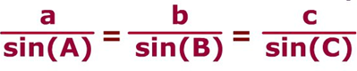
It works for any triangle:
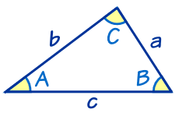 | a, b and c are sides.  A, B and C are angles.  (Side a faces angle A,  side b faces angle B and  side c faces angle C).
And it says that:
When we divide side a by the sine of angle A
it is equal to side b divided by the sine of angle B,
and also equal to side c divided by the sine of angle C

Sure ... ?
Well, let's do the calculations for a triangle I prepared earlier:
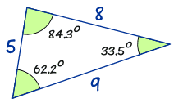
The answers are almost the same!
(They would be exactly the same if we used perfect accuracy).
So now you can see that:

